DOWNSCALING BUDYKO EQUATION FOR MONTHLY ACTUAL EVAPOTRANSPIRATION ESTIMATION OVER THE EMILIA-ROMAGNA REGION
Mărgărit-Mircea NISTOR^{,2}, Federico CERVI³
DOI: 10.21163/GT_ … … …

ABSTRACT:
This paper presents a modified Budyko equation (Budyko DOWNSCALED) for assessing actual evapotranspiration (AET0). The approach is tested by using 100 controlled and homogeneous meteorological stations located in the Emilia-Romagna region from North of Italy. A period of 55 years, from 1961-1990 and 1991-2015, was analyzed as long-term datasets of monthly values of precipitations, maximum and minimum temperatures. These data have allowed AET0 to be computed both at the yearly and the monthly scale with the Budyko ORIGINAL and Budyko DOWNSCALED formula, respectively. Results of both methods have been compared at the yearly scale, demonstrating that the Budyko DOWNSCALED approach almost correctly reproduces the annual AET0 values (R² equal to 0.77 and 0.73 for 1990s and 2015s, respectively) even if slightly underestimated (by 119 mm for 1990s and by 136 mm for 2015s). Further, monthly AET0 values were aggregated over a baseline period (between 1961 and 1990: 1990s) and a recent period (between 1991 and 2015: 2015s). In both baseline and recent periods, AET0 is higher in the summer months (May to September), while it is almost nil in winter season (January, February, and December). Monthly values of AET0 did not increase over the recent period as a result of increased temperatures. Further, this study contributes to the future management of water resources in the region.

Key-words: climate data, evapotranspiration, Budyko approach, Emilia-Romagna.

1. INTRODUCTION
Climate (here meant as the long-term averages of meteorological variables across a specific area) is the main driver of the surface water and groundwater resource renewal worldwide. Long-term changes in the amount of solid (snow) and liquid precipitations occurring at the soil surface may alter the recharge of surface water and groundwater. Evapotranspiration processes are influenced by several meteorological variables such as precipitations, humidity, wind and temperature. As a result, changes in the long-term trends of the above-mentioned variables lead to different precipitation quotas that return to the atmosphere by means of plant transpiration (Nistor et al., 2018).
Among the others, the Budyko formula is widely used to obtain estimates of the annual actual evapotranspiration (AET0). In this study, we use a 55-year long dataset (1961-2015) from 100 controlled and homogeneous meteorological stations located in the Emilia-Romagna region (northern Italy), an area in which clayshales widely outcrop and soil moisture changes in the upper part of the soil (to be intended as a thin weathered cover above the non-permeable materials) are somehow reduced. Moreover, several authors have already highlighted a precipitation reduction in the last century (Pavan et al., 2008; Pavanelli & Capra, 2014; Nistor & Mîndrescu, 2019; Haidu & Nistor, 2019). The latter became more intense starting from the 1990s (Tomozeiu et al., 2002; Pavan et al., 2008; Antolini et al., 2016) and has mainly affected the winter and spring seasons (Tomei et al., 2010). Moreover, from 1961 to 2010 the Emilia-Romagna region experienced an increase in the mean annual temperatures up to 0.5°C/decade for the period 1961–2010. Recently, Du et al. (2016) made a first attempt to adapt the Budyko formula to a monthly time-scale in an arid environment.

The main objective of this work is thus to test a Budyko DOWNSCALED formula for assessing AET0 at a monthly scale. The results of this work are promising as they confirm the reliability of this approach even under unsteady-state of the soil moisture. Annual AET0 obtained by both Budyko ORIGINAL and Budyko DOWNSCALED formulas are compared in order to check the reliability of the new tested method. For the sake of convenience, the former dataset is split into a reference period 1961–1990 (1990s) and a recent period 1991–2015 (2015s).

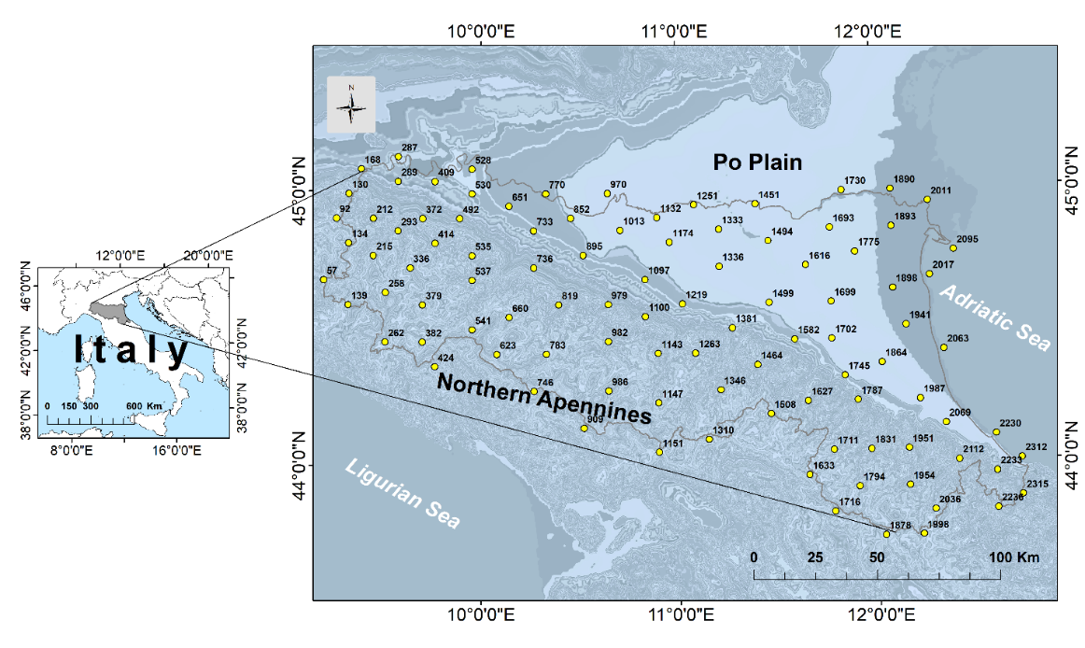
Fig. 1. Location of the Emilia-Romagna region on a map of Italy.
2. STUDY AREA
The Emilia-Romagna region is located in the northern Italy and is between 43°44’ and 45°08’ latitude North and between 9°11’ and 12°45’ longitude East (Fig. 1). The altitudes range from below 0 m in Po Plain to 2165 mm in Mt. Cimone.
The monthly precipitation varies from 37 mm to 211 mm (monthly average for 1961-1990), with higher values in the South-Western part of theregion and lower values on the North-Eastern part (Fig. 2). The recent period (1991-2015) indicates a monthly precipitation range from 34 mm to 309 mm (Fig. 3). In both the 1990s and 2015s periods, July experienced the most arid month with a large territory with values below 50 mm. During the 1990s, the mean annual temperature varied from 6.1 °C to 13.6 °C, while during the 2015s, the mean annual temperature varied from 7.1 °C to 15 °C.
The climatic characteristics of the region are closely related to the relief unit arrangements: northern Apennines mountains in South, South-West, and West, hilly areas in the central, West, and South-East parts, and Po Plain in the East, North, and North-West, and North-central parts of the region.

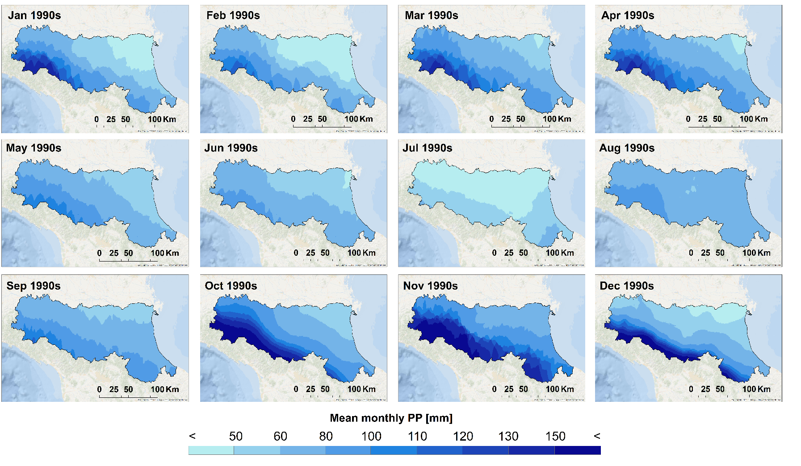
Fig. 2. Spatial distribution of monthly precipitation (PP) in the Emilia-Romagna region related to the1990s. Background image source: Esri, Garmin, GEBCO, NOAA NGDC, and other contributors.

Thus, we have measured flows of different nature. Table 1 shows an example of indicators of material and energy flows of urban environment for subsystem of city economy, which includes 16 indicators (see Fig. 2).
Table 1.
Example of indicators of material and energy flows of urban environment
(city economy subsystem)
Indicators of material  and energy flows |  | Designation | N(t) | P(t) | L(t) | Units of measurement
1. | Population density | I₁ |  |  |  | inhabit. /ha
2. | Building density | I₂ |  |  |  | m²/ha
3. | Building density coefficient | I₃ |  |  |  | m²/ha
.... .... ....
8. | Amount of household waste | I₈ |  |  |  | kg/inhabit.
.... .... ....
11. | Amounts of CO₂ emission from electricity generation | I₁₁ |  |  |  | kg/(m^{2 ·} year)
.... .... ....
16. | Share of using renewable energy sources | I₁₆ |  |  |  | %

Depending on types of spatial objects to which they are applied, indicators of material and energy flows can be generalized (have a single value) or distributed (over the territory or along the length of linear object). Distributed over the territory indicator I₂ – building density as a GRID-surface for cities Krivyi Rih, Odessa, Lugano and Barcelona are presented in Fig. 3 as an example.
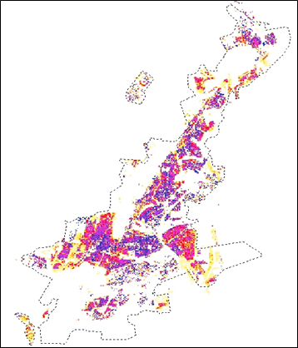
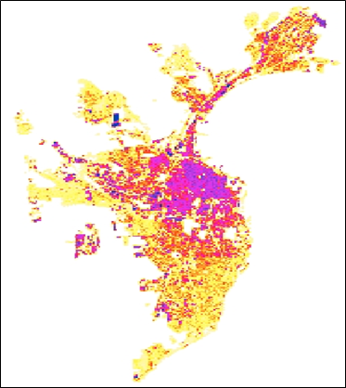
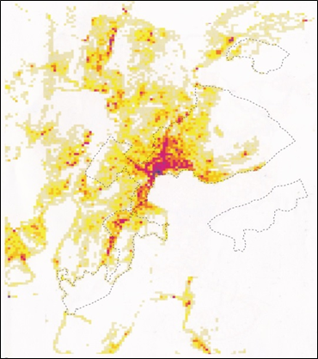
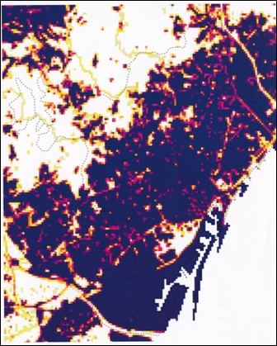
a)
b)
c)
d)

Fig. 3. Examples of indicator I₂ for cities (a) Krivyi Rih, (b) Odessa, (c) Lugano and (d) Barcelona.

3. DATA AND METHODS

3.1. Climate data
Three datasets of maximum and minimum monthly temperature and precipitation were used in this study. The climate data represent historical monthly records from 1961 to 2015. The datasets have been made freely available by Arpa Emilia-Romagna environmental agency (ARPA-EMR, 2019). In detail, these monthly datasets derived from the observed measurements of 100 meteorological stations uniformly distributed over the region. Antolini et al. (2016, 2017) have already verified the temporal homogeneity, synchronicity and consistency of these 100 meteorological stations.
It should be noted that the Budyko ORIGINAL approach results into the annual AET0.

3.2. Evapotranpiration calculation
3.2.1. Monthly Potential Evapotranspiration (ET0)
We decided to assess the monthly Potential Evapotranspiration (ET0) by using Thornthwaite method (1948) (Eq. (1)). This method assesses evapotranspiration by using the only the mean monthly temperature data. Even it has been used since the mid-20th century, this approach is still recognized as being appropriate for long-term studies requiring evapotranspiration estimates (Baltas, 2007; Čenčur Curk et al., 2014) and is suitable for climate and hydrological studies at a spatial scale (Zhao et al., 2013; Cheval et al., 2017).
The formula is expressed as follows:
${ET}_{0}={16bi(\frac{10T_{i}}{I} )}^{α}$ [mm/month] (1)

where:
ET₀ -potential evapotranspiration;
bi -radiation parameter for specific latitude (Table 1);
T_{i} ₋monthly air temperature;
I -annual heat index (see Eq. 2);
α -complex function of heat index (see Eq. 3)
$I=\sum_{i=1}^{12}{}{\left(\frac{T_{i}}{5}\right)}^{1.514}$ (2)
where: T_{i} = monthly air temperature
$α =6.75 ×{10}^{-7}I^{3}- 7.71×{10}^{-5}I^{2}+1.7912 ×{10}^{-2}I+0.49239$ (3)
where: I = annual heat index

3.2.3. Budyko DOWNSCALED for monthly AET0m
The procedure for Budyko DOWNSCALED approach (Eq. (6)) consists of using monthly variables instead of yearly ones. At this stage, the monthly precipitation (PPm) and monthly (ET0m) were used to carry out the monthly aridity index (Φm). Further, the Budyko formula was modified to calculate the monthly AET0m. The latter can be calculated as follows:

3.3. Validation of the Budyko DOWNSCALED approach for AET0m estimates
In order to validate our results, we compared in an x-y plot the mean annual AET0 obtained by Budyko ORIGINAL with the mean annual AET0 calculated by aggregating the AETm from the Budyko DOWNSCALED method. In detail, the mean annual AET0 (i.e., the annual actual evapotranspiration obtained as a unique mean value for both baseline and recent periods) has been obtained at each of the 100 meteorological stations by using Budyko (x-value) and Budyko DOWNSCALED (y-value). Then, a straight-line y=ax+b was fitted to the data by using the Ordinary Least Squares (OLS) method and regression was forced through 0 (i.e., a null value of AET0 calculated with Budyko must correspond to a null value of AET0 estimated with Budyko DOWNSCALED). OLS regression assumes the x values are fixed and finds the line which minimizes the squared errors in the y values (Davis, 2001). By using the OLS method, we assume that x values have very little error associated with them, i.e. we consider as correct actual evapotranspiration data those obtained by using the Budyko ORIGINAL. Goodness of fits are reported in form of correlation coefficient (R²).

4. RESULTS AND DISCUSSIONS
4.1. Validation of the Budyko DOWNSCALED approach for AET0m estimates
The annual AET0 from Budyko ORIGINAL and Budyko DOWNSCALED approaches have been compared by means of the OLS regression. Tests were carried out for both baseline (1990s) and recent (2015s) periods and evidenced that annual AET0 from Budyko ORIGINAL and Budyko DOWNSCALED were always correlated with similar goodness of fits (R²=0.77 for 1990s, Fig. 4; R² = 0.73 for 2015s, Fig. 5). Equations characterizing the regression lines are also similar (y=0.78x for 1990s and y=0.76x for 2015s) and indicates that Budyko DOWNSCALED slightly underestimated the annual AET0 values as calculated by the Budyko ORIGINAL approach.

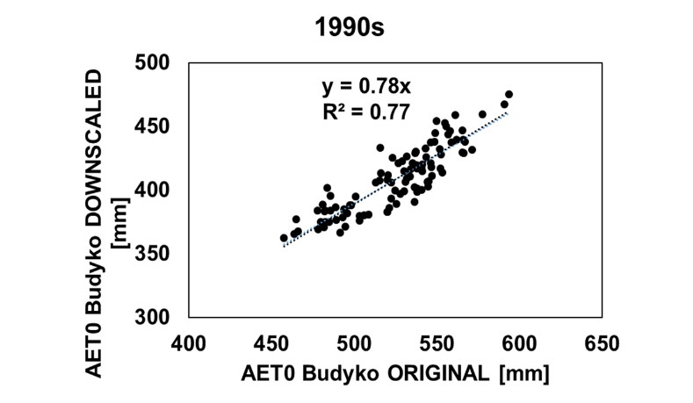
Fig. 4. Statistical analysis of annual AET0 values between the Budyko ORIGINAL and Budyko DOWNSCALED for the 1990s.

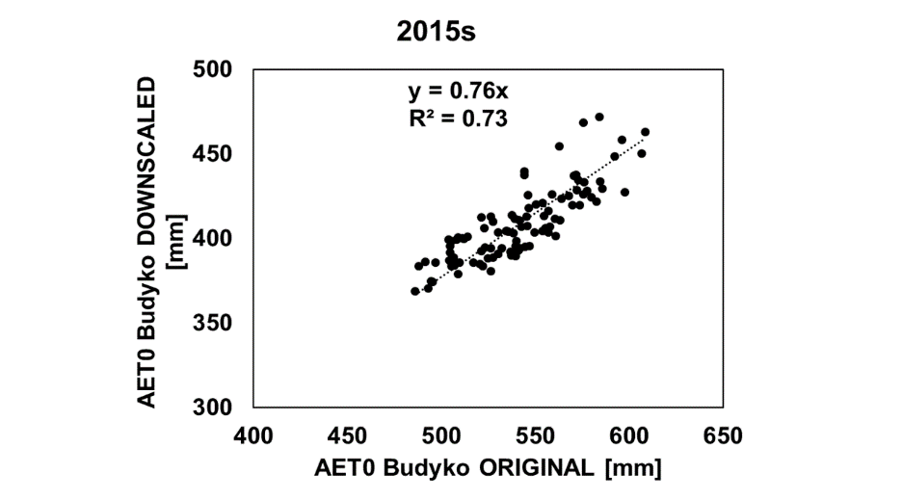
Fig. 5. Statistical analysis of annual AET0 values between the Budyko ORIGINAL and Budyko DOWNSCALED for the 2015s.

4.2. Evaluation and mapping of monthly AET0m

The variation of monthly actual evapotranspiration AET0m is related to the monthly ET0m and monthly precipitation PPm. As expected, AET0m values as calculated by the whole dataset of meteorological stations are almost lower than the corresponding ET0m for both baseline (1990s) and recent (the 2015s) periods. No remarkable changes can be evidenced between baseline and recent periods if we exclude the summer months of July and August, when the 2015s were characterized by lower values of this parameter. In particular, and for the 1990s period, the Budyko DOWNSCALED method allowed us to calculate values of monthly AET0m between 0.7 mm (January) mm to 68 mm (August). Spatial analysis indicates that higher values were found in the central part of the Northern Apennines, while the lowest values were detected in the northern part of the region (lowlands; Fig. 6). During the 2015s, the monthly AET0m varied from 2.2 mm (January) to 68 mm (June). Being controlled by the temperatures, the highest AET0m values were identified in the lowland areas while the lower ones along the main watershed divide of the northern Apennines (Fig. 7).
For both the 1990s and the 2015s periods, the lowest values (below 10 mm) of AET0m were found in the winter (December, January, February). During the months of March, April, May, September, October, and November, the AET0m variation showed values between 10 mm and about 60 mm for both periods.

Table 2.
The water-saving strategies adopted by the dive resorts in Pemuteran, Bali.
No | Strategies | Number of Users | Dive Resorts
1 | Applying recycling technology for toilet wastewater and reusing the treated water for the plants | 1 | 5
2 | Adding chemical ingredients and equipment to clear the swimming pool water | 4 | 1, 2, 4, 8
3 | Installing a water purifier for the fish ponds | 1 | 2
4 | Constructing infiltration wells | 1 | 6
5 | Providing water in gallons instead of plastic bottles | 1 | 8
6 | Using sprinklers to water the plants | 4 | 5, 7, 8, 9
7 | Reusing the wastewater from dive-gear washing to water the plants | 2 | 4, 3
8 | Using household appliances made of thin materials | 1 | 5

Table 3.
The response of informants to the water scarcity issue in Pemuteran, Bali (in %).
No | Questions | Yes | No
1 | Do you know that Bali is projected to suffer water shortages? | 46% | 54%
2 | Do you know that Buleleng Regency is experiencing water shortages? | 15% | 85%
3 | Do you encounter difficulties in accessing water? | 31% | 69%
4 | Do you care about the water problems in Pemuteran Village? | 100% | 0%
5 | Have you tried any strategies to save water? | 100% | 0%
6 | Do you know that the tourism industry uses up to 65% of available water in Bali? | 69% | 31%
7 | Are you willing to support any efforts that the government and community perform to save water? | 100% | 0%

Fig. 2. Information model of the interaction of subsystem of city economy with the environment.

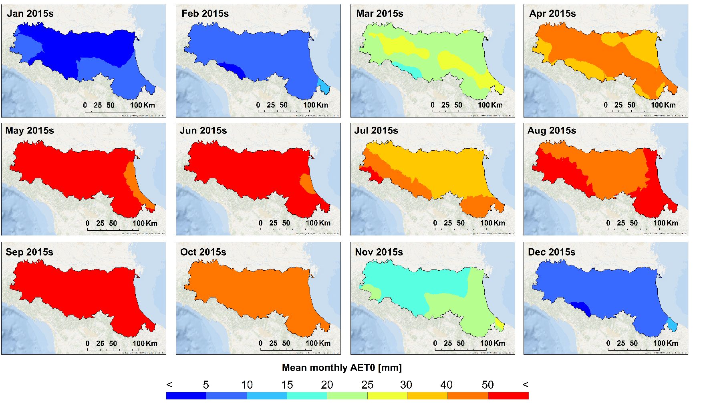
Fig. 7. Spatial distribution of monthly actual evapotranspiration (AET0) in the Emilia-Romagna region related to the 2015s. Background image source: Esri, Garmin, GEBCO, NOAA NGDC, and other contributors.

4.3. Mapping of the annual AET0
During the 1990s, the variation of annual AET0 carried out by Budyko ORIGINAL shows values between 458 mm to 589 mm and by Budyko DOWNSCALED (as sum of the 12 months) the values of annual AET0 vary from 362 mm to 470 mm. During 2015s, Budyko ORIGINAL indicates values between 485 m to 606 mm for annual AET0, while Budyko DOWNSCALED (as sum of the 12 months) indicates values between 369 mm to 470 mm. For both analyzed periods, the higher values of annual AET0 were depicted in the Northern Apennines and the lower values in the Po Plain. Interestingly, the area with high annual AET0 increased in the 2015s under Budyko ORIGINAL approach, while under Budyko DOWNSCALED, the pattern of the annual AET0 remained almost the same (Fig. 8).
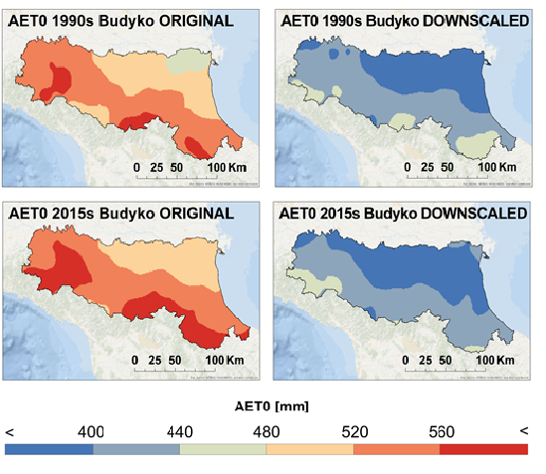
Fig. 8. Spatial distribution of annual AET0 in the Emilia-Romagna region. Background image source: Esri, Garmin, GEBCO, NOAA NGDC, and other contributors.
5. DISCUSSION
Goodness of fits by the regression lines between yearly actual evapotranspiration AET0 obtained by original and downscaled methods demonstrate that the results are correlated both in the case of the 1990s (R²=0.77) and the 2015s (R²=0.73). Regression lines slopes are similar (0.78 and 0.76, respectively) and evidenced that Budyko DOWNSCALED slightly underestimated the yearly actual evapotranspiration as compared with the Budyko ORIGINAL.
This fact is probably related to the non-perfect compliance with the assumption of steady-state in case of the Budyko DOWNSCALED approach; this means that by passing from month to month the soil moisture varies and therefore the system is in a non-stationary state (unsteady state). Nonetheless, it should be noted that the underestimates are somehow reduced (about 20%) and similar for both baseline and recent periods, a value which makes it possible to state that the estimates of the monthly parameters are suitable for the comparison of different time-periods.
From the results, it was observed that the annual AET0 carried out by Budyko ORIGINAL indicates higher values than Budyko DOWNSCALED. The difference is about 120 mm respective 130 mm (i.e. 470 mm vs. 606 mm) for the maxima while for the minima, the difference is about 100 mm (i.e. 362 mm vs. 458 mm). These differences are influenced by the monthly precipitation and evapotranspiration regime. Budyko DOWNSCALED performs the cumulated annual AET0in good agreement with the Budyko ORIGINAL. However, the annual AET0 carried out using Budyko DOWNSCALED is lower than AET0 carried out by Budyko ORIGINAL. There are two reasons for the sub-estimation of Budyko DOWNSCALED. First, the sub-estimation of the Budyko DOWNSCALED in comparison to the Budyko ORIGINAL are due to the lower values of the aridity index (ET0/PP) in winter months. In that situation, the aridity index is influenced by low mean monthly temperatures, especially in the mountain stations. Secondly, the precipitation amount in the summer season is too low to be subtracted for the AET0. This indicates that in the months with high temperatures and high ET0, the monthly AET0 by Budyko DOWNSCALED remains low because of a lack of water from precipitation. This effect is not accounted for in the annual AET0 calculation by Budyko ORIGINAL. Du et al. (2016) observed that the local precipitation influences the overall application of Budyko at the local scale. Mianabadi et al. (2017) mentioned that the Budyko curves expressed in the Gerrits (2009) model are sensitive to the number of rain days and months especially for the higher precipitation rates.
6. CONCLUSIONS
The current study demonstrates the usefulness of the Budyko DOWNSCALED approach to estimate the mean monthly values of actual evapotranspiration (AET0m) by exploiting long time series of monthly temperature and precipitation datasets from a temperate area. We have used datasets from 100 meteorological stations spread over the Emilia-Romagna region and consisting of monthly data of temperatures and precipitations from 1961 to 2015. Time-series have been split into two time periods (baseline 1990s and recent 2015s) allowing for a comparison of the yearly averaged actual evapotranspiration values as obtained with the original and downscaled methods. The results highlight that averaged annual AET0 from both methods are strongly correlated (R² equal to 0.78 and 0.73, respectively) even if those from Budyko DOWNSCALED are slightly underestimated (about 20%). Although the Budyko DOWNSCALED slightly underestimates the final AET0 values, similar values of underestimation between the 1990s and the 2015s confirm the suitability for the comparison of AET0m from different periods.
The increase of the AET0 in the Emilia-Romagna region over the recent period (2015s) influences the recharge of rivers and aquifers both in the mountains and the plain. The results carried out here and the original maps could be useful instruments for the plan risk and water resources management in the region.

REFERENCES

Antolini, G., Auteri, L., Pavan, V., Tomei, F., Tomozeiu, F. & Marletto, V. (2016) A daily high-resolution gridded climatic data set for Emilia-Romagna, Italy, during 1961-2010. International Journal of Climatology, 36, 1970–1986.
Antolini G. et al. (2017) Atlante Climatico dell’Emilia-Romagna 1961-2015. Casma Tipolito, Bologna, Italy.
ARPAE-EMR, 2019. Regional agency for environmental protection in Emilia-Romagna Region:Analisi climatica giornaliera 1961-2015. Last access on September 2019, https://www.arpae.it/dettaglio_documento.asp?id=6147&idlivello=1528.
Baltas, E. (2007) Spatial distribution of climatic indices in northern Greece. Meteorological Applications, 14, 69–78.
Budyko, M.I. (1974) Climate and Life. Academic Press, New York, USA, p. 508.
Čenčur Curk, B., Cheval, S., Vrhovnik, P., Verbovšek, T., Herrnegger, M., Nachtnebel, H.P., Marjanović, P., Siegel, H., Gerhardt, E., Hochbichler, E., Koeck, R., Kuschnig, G., Senoner, T., Wesemann, J., Hochleitner, M., Žvab Rožič, P., Brenčič, M., Zupančič, N., Bračič Železnik, B., Perger, L., Tahy, A., Tornay, E.B., Simonffy, Z., Bogardi, I., Crăciunescu, A., Bilea, I.C., Vică, P., Onuţu, I., Panaitescu, C., Constandache, C., Bilanici, A., Dumitrescu, A., Baciu, M., Breza, T., Marin, L., Draghici, C., Stoica, C., Bobeva, A., Trichkov, L., Pandeva, D., Spiridonov, V., Ilcheva, I., Nikolova, K., Balabanova, S., Soupilas, A., Thomas, S., Zambetoglou, K., Papatolios, K., Michailidis, S., Michalopoloy, C., Vafeiadis, M., Marcaccio, M., Errigo, D., Ferri, D., Zinoni, F., Corsini, A., Ronchetti, F., Nistor, M.M., Borgatti, L., Cervi, F., Petronici, F., Dimkić, D., Matić, B., Pejović, D., Lukić, V., Stefanović, M., Durić, D., Marjanović, M., Milovanović, M., Boreli-Zdravković, D., Mitrović, G., Milenković, N., Stevanović, Z., & Milanović, S. (2014) CC-WARE Mitigating Vulnerability of Water Resources under Climate Change. WP3 - Vulnerability of Water Resources in SEE, Report Version 5. URL: http://www.ccware.eu/output-documentation/output-wp3.html.
Cheval, S., Dumitrescu, A. & Barsan, M.V. (2017) Variability of the aridity in the South-Eastern Europe over 1961–2050. Catena, 151, 74–86.
Du, C., Sun, F., Yu, J., Liu, X. & Chen, Y. (2016) New interpretation of the role of water balance in an extended Budyko hypothesis in arid regions. Hydrol. Earth Syst. Sci., 20, 393–409.
Fathi, M. M., Awadallah, A. G., Abdelbaki, A. M. & Haggag, M. (2019) A new Budyko framework extension using time series SARIMAX model. Journal of Hydrology, 570, 827–838.
Gerrits, A. M. J., Savenije, H. H. G., Veling, E. J. M. & Pfister, L. (2009) Analytical derivation of the Budyko curve based on rainfall characteristics and a simple evaporation model. Water Resources Research, 45(W04403): 1–15, DOI: 10.1029/2008WR007308.
Greve, P., Gudmundsson, L., Orlowsky, B. & Seneviratne, S. I. (2016) A two-parameter Budyko function to represent conditions under which evapotranspiration exceeds precipitation. Hydrol. Earth Syst. Sci., 20: 2195–2205.
Haidu, I. & Nistor, M.M. 2019. Long-term effect of climate change on groundwater recharge in the Grand Est region, France. Meteorological Applications, doi: 10.1002/met.1796.
Mianabadi, A., Coenders–Gerrits, M., Shirazi, P., Ghahraman, B. and Alizadeh, A. (2019) A simple global Budyko model to partition evaporation into interception and transpiration. Hydrol. Earth Syst. Sci. Discuss., https://doi.org/10.5194/hess-2017-306.
Nistor, M. M., Man, T. C., Benzaghta, M.A., Vaasu, N. N., Dezsi, S., Kizza, R. (2018) Land cover and temperature implications for the seasonal evapotranspiration in Europe. Geographia Technica, 13 (1), 85-108.
Nistor, M. M. & Mîndrescu, M. (2019) Climate change effect on groundwater resources in Emilia-Romagna region: An improved assessment through NISTOR-CEGW method. Quaternary International, 504, 214-228.
Pavan, V., Tomozeiu, R., Cacciamani, C. & Di Lorenzo, M. (2008) Daily precipitation observations over Emilia-Romagna: mean values and extremes. International Journal of Climatology, 28 (15), 2065–2079.
Pavanelli, D. & Capra, A. (2014) Climate change and human impacts on hydroclimatic variability in the Reno river catchment, Northern Italy. CLEAN-Soil Air Water, 42 (5), 1–11.
Thornthwaite, C.W. (1948) An approach toward a rational classification of climate. Geographical Review, 38, 55–94.
Tomei, F., Antolini, G., Tomozeiu, R., Pavan, V., Villani, G. & Marletto, V. (2010) Analysis of precipitation in Emilia-Romagna (Italy) and impacts of climate change scenarios, in Proceedings of Statistics in Hydrology Working Group (STAHYWG) International Workshop, pp. 23–25, Taormina, Italy, May 2010.
Tomozeiu, R., Lazzeri, M. & Cacciamani, C. (2002) Precipitation fluctuations during the winter season from 1960 to 1995 over Emilia-Romagna, Italy. Theoretical and Applied Climatology, 72 (3-4), 221–229.
Zhao, L., Xia, J., Xu, C., Wang, Z, Sobkowiak, L. & Long, C. (2013) Evapotranspiration estimation methods in hydrological models. Journal of Geographical Sciences, 23 (2), 359–369.

1Nanyang Technological University, School of Civil and Environmental Engineering, Singapore ²Department of Hydrogeology, Earth research Company, Cluj-Napoca, Romania, renddel@yahoo.com ³Scientific High School Aldo Moro, Reggio Emilia, Italy, fd.cervi@gmail.com.

